**Dahlia Bouquet**

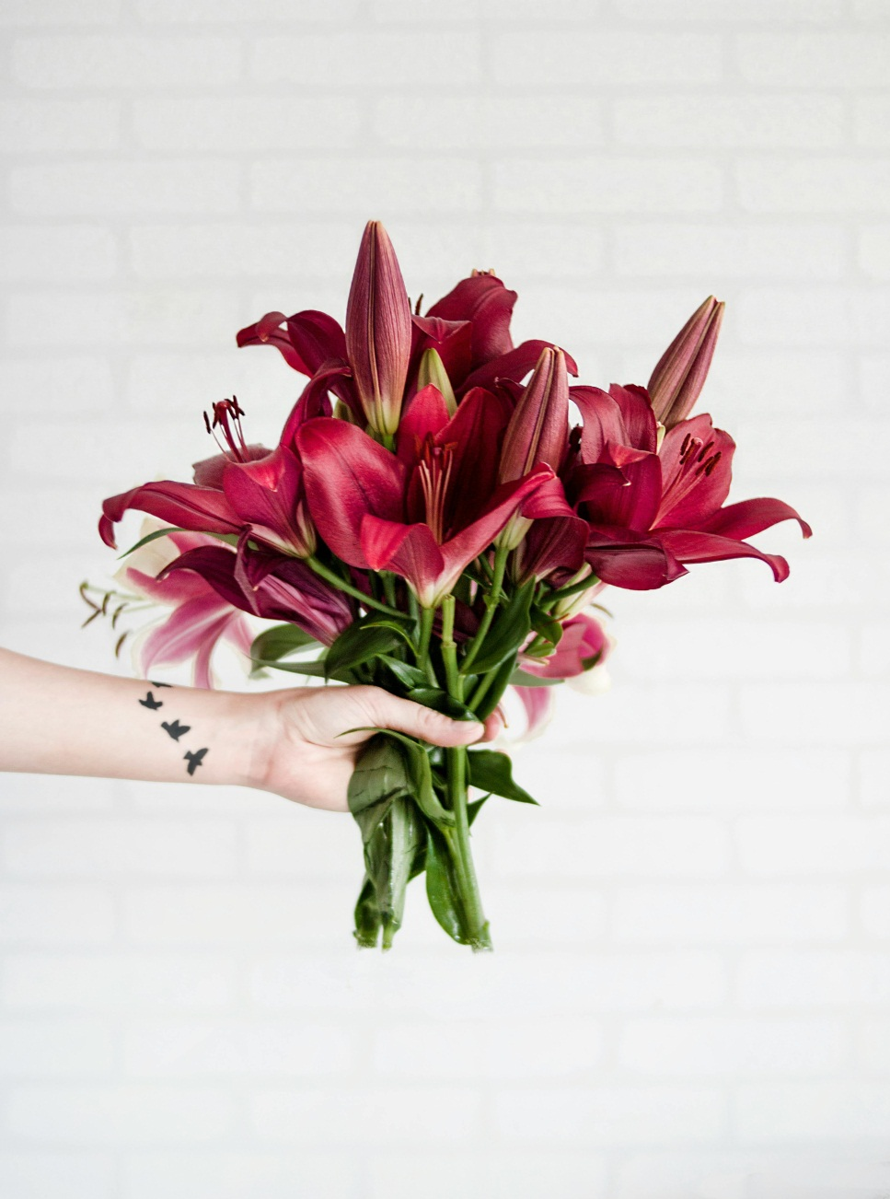

The Dahlia Bouquet is a stunning floral arrangement featuring a variety of vibrant dahlia flowers. Each bouquet is carefully curated to showcase the beauty and diversity of dahlias, ranging in colors from deep reds and oranges to soft pinks and whites. With their intricate layers of petals and rich hues, these bouquets make a striking centerpiece for any occasion, adding elegance and charm to any space. Whether as a gift or for personal enjoyment, the Dahlia Bouquet is sure to delight with its natural beauty and lasting freshness.

**CATEGORIES:** Classic Elegance,Vibrant Garden,Rustic Charm,Modern Romance,Whimsical Wonderland.

**INFORMATION**: Dahlia flower meanings include beauty, eternal love, inner strength, dignity, and kindness. Depending on the flower color, context, and culture, dahlias symbolize themes of celebration, relationships, and resilience.

**Price**: ~~$29.00~~ $20.00